**EXPERIMENT – 1**

**Aim:**

To study various DDL commands – CREATE

1. CREATE DATABASE Bank_details ;

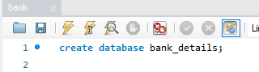

1. CREATE TABLE DEPOSIT (

ACTNO VARCHAR(5) PRIMARY KEY CHECK (ACTNO LIKE 'D%'),

CNAME VARCHAR(15) REFERENCES CUSTOMER(CNAME),

BNAME VARCHAR(20) REFERENCES BRANCH(BNAME),

AMOUNT DECIMAL(8,2) NOT NULL CHECK (AMOUNT > 0),

ADATE DATE

);

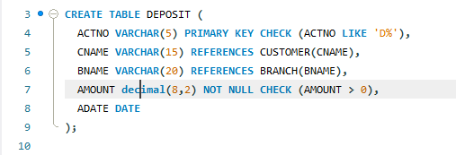



1. CREATE TABLE CUSTOMER (

CNAME VARCHAR(15) PRIMARY KEY,

CITY VARCHAR(30) NOT NULL

);

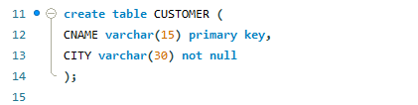



1. CREATE TABLE BRANCH (

BNAME VARCHAR(20) PRIMARY KEY,

CITY VARCHAR(30) CHECK(CITY IN ('NAGPUR','DELHI',

'BANGLORE','BOMBAY'))NOT NULL

);

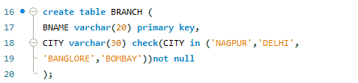



1. CREATE TABLE BORROW (

LOANNO VARCHAR(8) check(LOANNO like 'L%') primary key,

CNAME VARCHAR(15) REFERENCES CUSTOMER(CNAME),

BNAME VARCHAR(20) REFERENCES BRANCH(BNAME),

AMOUNT FLOAT(8) NOT NULL CHECK (AMOUNT > 0)

);

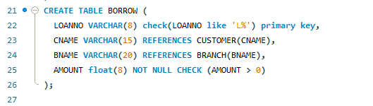



**INSERTION OF VALUES**

1. **Inserting values to CUSTOMER**

INSERT INTO CUSTOMER (CNAME, CITY) VALUES ('ANIL', 'CALCUTTA');

INSERT INTO CUSTOMER (CNAME, CITY) VALUES ('SUNIL', 'DELHI');

INSERT INTO CUSTOMER (CNAME, CITY) VALUES ('MEHUL', 'BARODA');

INSERT INTO CUSTOMER (CNAME, CITY) VALUES ('MANDAR', 'PATNA');

INSERT INTO CUSTOMER (CNAME, CITY) VALUES ('MADHURI', 'NAGPUR');

INSERT INTO CUSTOMER (CNAME, CITY) VALUES ('PRAMOD', 'NAGPUR');

INSERT INTO CUSTOMER (CNAME, CITY) VALUES ('SANDIP', 'SURAT');

INSERT INTO CUSTOMER (CNAME, CITY) VALUES ('SHIVANI', 'BOMBAY');

INSERT INTO CUSTOMER (CNAME, CITY) VALUES ('KRANTI', 'BOMBAY');

INSERT INTO CUSTOMER (CNAME, CITY) VALUES ('NAREN', 'BOMBAY');

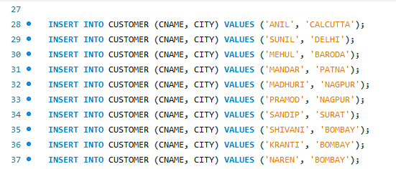

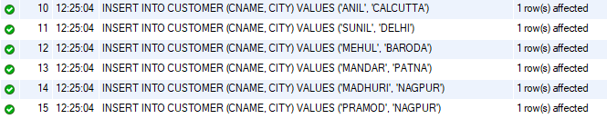 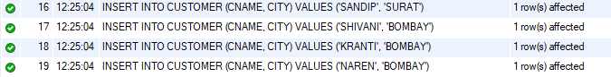

1. **Inserting values to BRANCH**

INSERT INTO BRANCH (BNAME, CITY) VALUES ('VRCE', 'NAGPUR');

INSERT INTO BRANCH (BNAME, CITY) VALUES ('AJNI', 'NAGPUR');

INSERT INTO BRANCH (BNAME, CITY) VALUES ('KAROLBAGH', 'DELHI');

INSERT INTO BRANCH (BNAME, CITY) VALUES ('CHANDNI', 'DELHI');

INSERT INTO BRANCH (BNAME, CITY) VALUES ('DHARAMPETH', 'NAGPUR');

INSERT INTO BRANCH (BNAME, CITY) VALUES ('MG ROAD', 'BANGLORE');

INSERT INTO BRANCH (BNAME, CITY) VALUES ('ANDHERI', 'BOMBAY');

INSERT INTO BRANCH (BNAME, CITY) VALUES ('NEHRU PALACE', 'DELHI');

INSERT INTO BRANCH (BNAME, CITY) VALUES ('POWAI', 'BOMBAY');

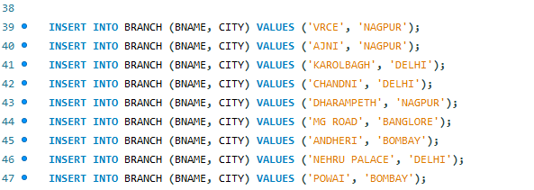

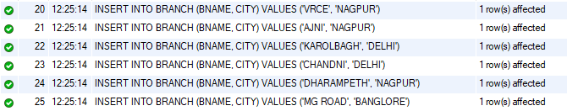 

1. **Inserting values to BORROW**

INSERT INTO borrow (LOANNO, CNAME, BNAME, AMOUNT)

VALUES ('L201', 'ANIL', 'VRCE', 1000.00);

INSERT INTO borrow (LOANNO, CNAME, BNAME, AMOUNT)

VALUES ('L206', 'MEHUL', 'AJNI', 5000.00);

INSERT INTO borrow (LOANNO, CNAME, BNAME, AMOUNT)

VALUES ('L311', 'SUNIL', 'DHARAMPETH', 3000.00);

INSERT INTO borrow (LOANNO, CNAME, BNAME, AMOUNT)

VALUES ('L321', 'MADHURI', 'ANDHERI', 2000.00);

INSERT INTO borrow (LOANNO, CNAME, BNAME, AMOUNT)

VALUES ('L371', 'PRAMOD', 'VIRAR', 8000.00);

INSERT INTO borrow (LOANNO, CNAME, BNAME, AMOUNT)

VALUES ('L481', 'KRANTI', 'NEHRU PLACE', 3000.00);

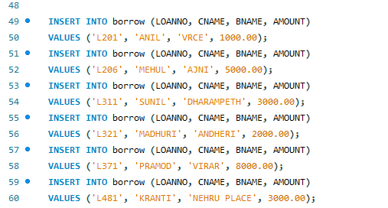

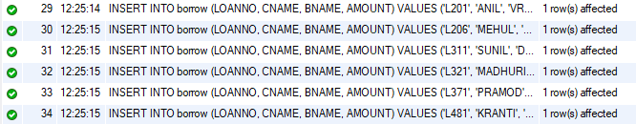

1. **Inserting values to DEPOSIT**

INSERT INTO Deposit (ACTNO, CNAME, BNAME, AMOUNT, ADATE)

VALUES ('D100', 'ANIL', 'VRCE', 1000.00, '1995-03-01');

INSERT INTO Deposit (ACTNO, CNAME, BNAME, AMOUNT, ADATE)

VALUES ('D101', 'SUNIL', 'ANJNI', 500.00, '1996-01-04');

INSERT INTO Deposit (ACTNO, CNAME, BNAME, AMOUNT, ADATE)

VALUES ('D102', 'MEHUL', 'KAROLBAGH', 3500.00, '1995-11-17');

INSERT INTO Deposit (ACTNO, CNAME, BNAME, AMOUNT, ADATE)

VALUES ('D104', 'MADHURI', 'CHANDNI', 1200.00, '1995-12-17');

INSERT INTO Deposit (ACTNO, CNAME, BNAME, AMOUNT, ADATE)

VALUES ('D105', 'PRAMOD', 'MG ROAD', 3000.00, '1996-03-27');

INSERT INTO Deposit (ACTNO, CNAME, BNAME, AMOUNT, ADATE)

VALUES ('D106', 'SANDIP', 'ANDHERI', 2000.00, '1996-03-31');

INSERT INTO Deposit (ACTNO, CNAME, BNAME, AMOUNT, ADATE)

VALUES ('D107', 'SHIVANI', 'VIRAR', 1000.00, '1995-09-05');

INSERT INTO Deposit (ACTNO, CNAME, BNAME, AMOUNT, ADATE)

VALUES ('D108', 'KRANTI', 'NEHRU PLACE', 5000.00, '1995-07-02');

INSERT INTO Deposit (ACTNO, CNAME, BNAME, AMOUNT, ADATE)

VALUES ('D109', 'MINU', 'POWAI', 7000.00, '1995-08-10');

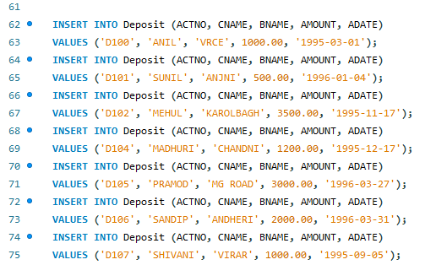 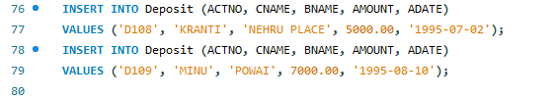

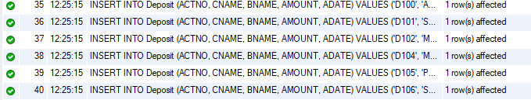 

1. List all data from table deposit

SELECT * FROM Deposit;

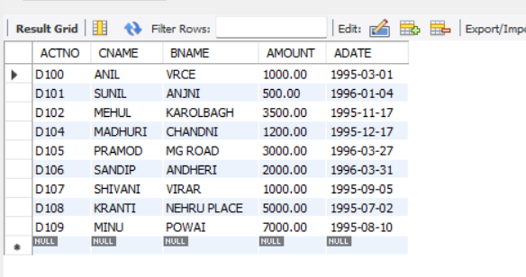

1. List all data from borrow

SELECT * FROM borrow;

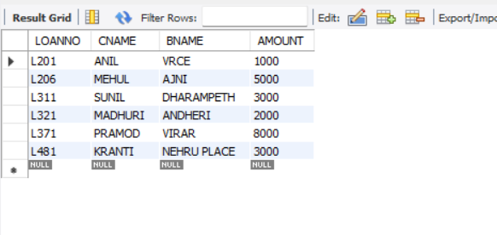

1. List all data from customer

SELECT * FROM customer;

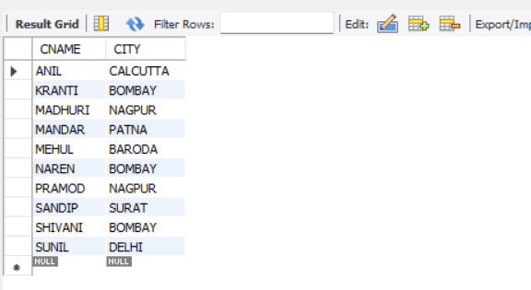

1. List all data from branch

SELECT * FROM branch;

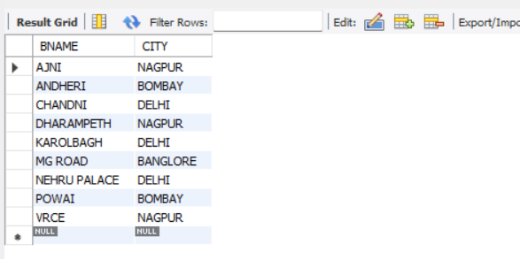

1. Give account no and amount of deposit

SELECT actno, amount FROM deposit;

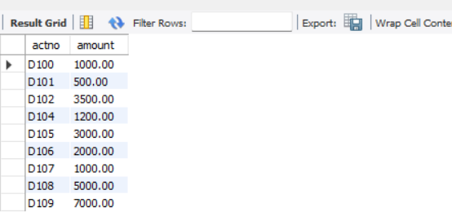

1. Give customer name and account no of depositors

SELECT CNAME, ACTNO FROM DEPOSIT;

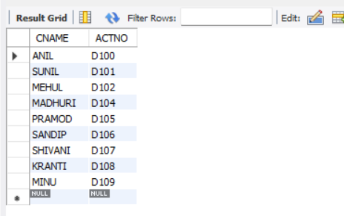

1. Give name of customers

SELECT CNAME FROM CUSTOMER;

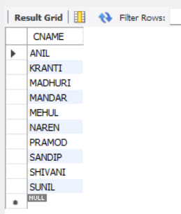

1. Give name of branches

SELECT BNAME FROM BRANCH;

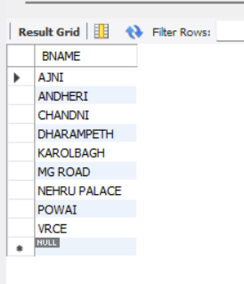

1. Give name of borrows

SELECT CNAME FROM BORROW;

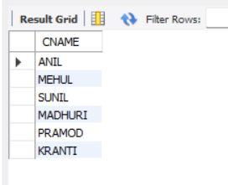

1. Give names of customer living in city Nagpur

SELECT CNAME FROM CUSTOMER WHERE CITY = 'NAGPUR';

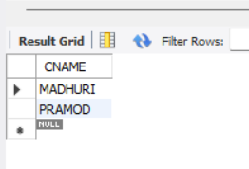

1. Give names of depositors having amount greater than 4000

SELECT CNAME FROM DEPOSIT WHERE AMOUNT > 4000;

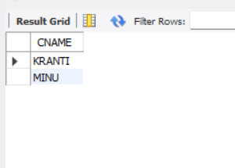

1. Give account date of Anil

SELECT ADATE FROM DEPOSIT WHERE CNAME = 'Anil';

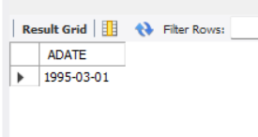

1. Give name of all branches located in Bombay

SELECT BNAME FROM BRANCH WHERE CITY = 'BOMBAY';

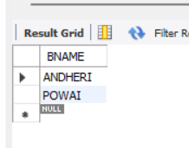

1. Give name of borrower having loan number l205

SELECT CNAME FROM BORROW WHERE LOANNO = 'l205';

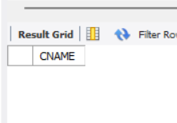

1. Give names of depositors having account at VRCE

SELECT CNAME FROM DEPOSIT WHERE BNAME = 'VRCE';

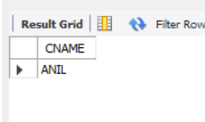

1. Give names of all branched located in city Delhi

SELECT BNAME FROM BRANCH WHERE CITY = 'DELHI';

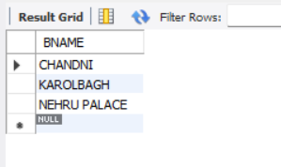

1. Give name of the customers who opened account date ‘1-12-96’

SELECT CNAME FROM DEPOSIT WHERE ADATE = '1996-12-01';

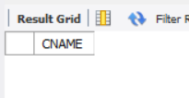

1. Give account no and deposit amount of customers having account opened between dates ‘1- 12-96’ and ‘1-5-96’

SELECT ACTNO, AMOUNT FROM DEPOSIT WHERE ADATE BETWEEN '01-DEC-96' AND '01-MAY-96';

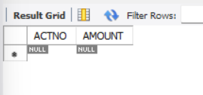

1. Give name of the city where branch KAROL BAGH is located

SELECT CITY FROM BRANCH WHERE BNAME = 'KAROLBAGH';

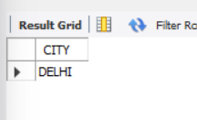

1. Give details of customer ANIL

SELECT * FROM DEPOSIT WHERE CNAME = 'Anil';

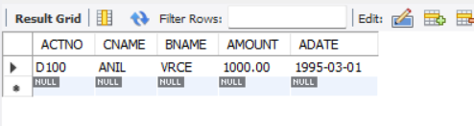

**EXPERIMENT 3:**

**Aim:**

To familiarize DDL Commands- ALTER, DROP, TRUNCATE, RENAME

**CO 1:**

Design and build a simple relational database system and demonstrate competence with the fundamentals tasks involved with modelling, designing and implementing a database.

**Procedure:**

1. Create a table ‘emp’ with attributes empno int(4)as primary key, ename char(10), hiredate, salary, commission and insert the following 5 rows of data:

| 101 | Ramesh | 17-Jan-1980 | 5000 |  |
| --- | --- | --- | --- | --- |
| 102 | Ajay | 05-Jul-1985 | 5000 | 500 |
| 103 | Ravi | 12-Aug-1981 | 1500 |  |
| 104 | Nikesh | 03-Mar-1983 | 3000 | 700 |
| 105 | Ravi | 05-Jul-1985 | 3000 |  |

* Database Creation:

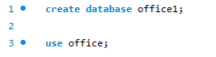



* Table Creation:

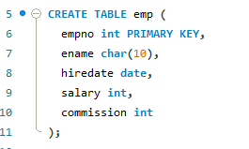 

* Insertion of tables :

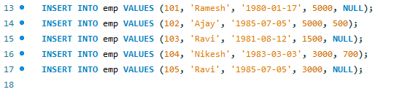

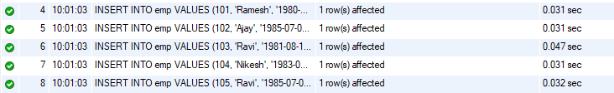

* Viewing the entered Data:



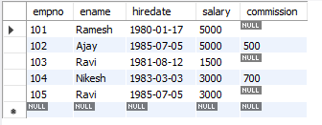

1. Add check constraint (Salary >=1500)

 

1. Add Check Constraint (length(empno<=3))

 

1. Modifying the structure of tables:
2. Add new columns: sal int)





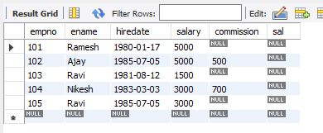

1. Dropping a column from a table: sal





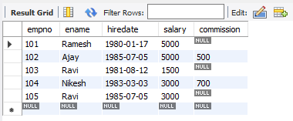

1. Modifying existing column :ename varchar(15)

 

1. Renaming the tables: emp to emp1

 



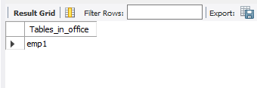

1. truncating the tables:emp1

 

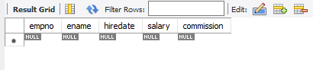

1. Destroying tables:emp





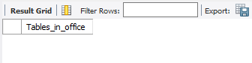

**Aim**

To familiarize with set operations

1. List all the customers who are depositors but not borrowers.

SELECT CNAME FROM deposit WHERE CNAME NOT IN (SELECT CNAME FROM borrow);

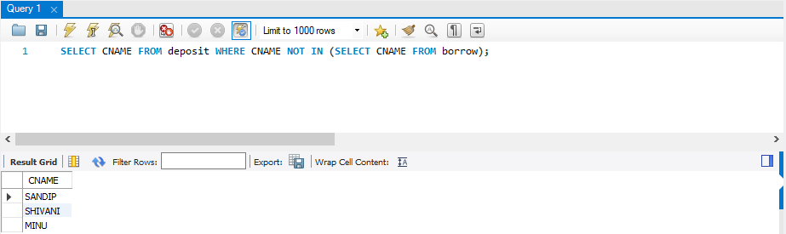

2. List all the customers who are both depositors and borrowers

SELECT CNAME FROM DEPOSIT UNION (SELECT CNAME FROM BORROW);

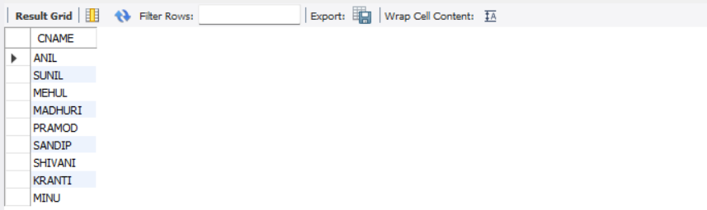

3. List all the depositors having deposit in all the branches where Sunil is having Account

SELECT D1.CNAME FROM DEPOSIT D1 WHERE D1.BNAME IN (SELECT D2.BNAME FROM DEPOSIT D2 WHERE D2.CNAME = 'SUNIL' );

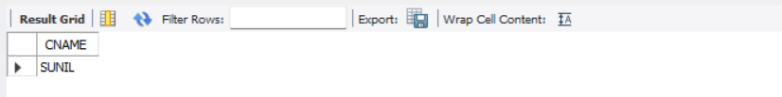

4. List all the customers living in city NAGPUR and having branch city BOMBAY or DELHI

SELECT C1.CNAME FROM CUSTOMER C1,DEPOSIT D1, BRANCH B1 WHERE C1.CITY = 'NAGPUR' AND C1.CNAME = D1.CNAME AND D1.BNAME = B1.BNAME AND B1.CITY IN ('BOMBAY','DELHI');

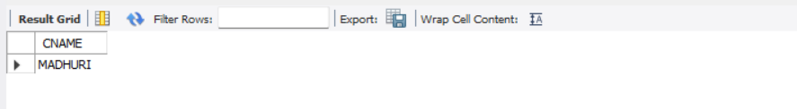

5. List all the depositors living in city NAGPUR

SELECT DISTINCT(CUSTOMER.CNAME) from CUSTOMER,DEPOSIT WHERE City='NAGPUR';

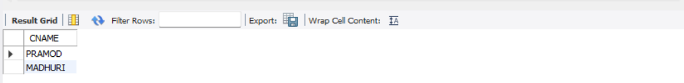

6. List all the depositors living in the city NAGPUR and having branch in city BOMBAY

SELECT C1.CNAME FROM CUSTOMER C1,DEPOSIT D1, BRANCH B1 WHERE C1.CITY = 'NAGPUR' AND C1.CNAME = D1.CNAME AND D1.BNAME = B1.BNAME AND B1.CITY IN ('BOMBAY');



7. List the branch cities of Anil and Sunil

SELECT B1.CITY FROM DEPOSIT D1, BRANCH B1 WHERE D1.BNAME = B1.BNAME AND D1.CNAME IN ('SUNIL' ,'ANIL');

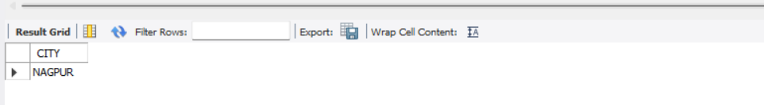

8. List the customers having deposit greater than 1000 and loan less than 10000.

SELECT DISTINCT D1.CNAME FROM deposit D1, borrow B1 WHERE D1.AMOUNT>1000 AND B1.AMOUNT<10000;

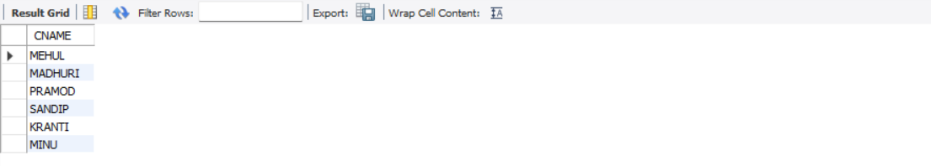

9. List the cities of depositors having branch VRCE.

SELECT B1.CITY FROM deposit D1, branch B1 WHERE D1.BNAME=B1.BNAME AND B1.BNAME='VRCE';

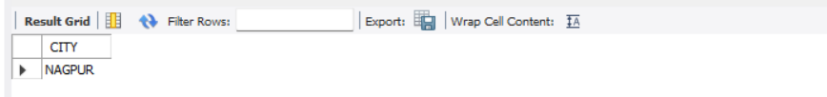

10. List the depositors having amount less than 1000 and living in the same city as Anil

SELECT D1.CNAME FROM deposit D1, customer C1 WHERE AMOUNT<1000 AND C1.CITY=(C1.CNAME='ANIL');

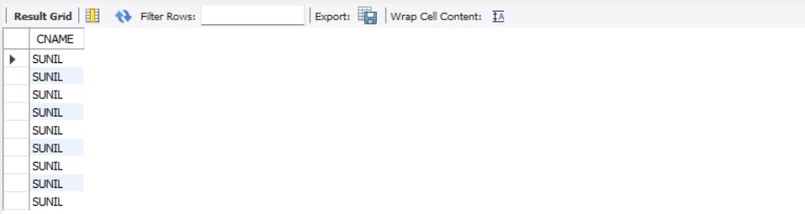

11. List all the cities where branches of Anil and Sunil are locate

SELECT B1.CITY FROM BRANCH B1 WHERE B1.BNAME IN (SELECT D1.BNAME FROM DEPOSIT D1 WHERE D1.CNAME IN ('ANIL','SUNIL'));



12. List the amount for the depositors living in the city where Anil is living

SELECT DISTINCT(D1.CNAME),D1.AMOUNT ,C1.CITY FROM deposit D1, CUSTOMER C1, BRANCH B1 WHERE D1.CNAME=C1.CNAME AND C1.CITY IN(SELECT C2.CITY FROM customer C2 WHERE C2.CNAME='ANIL');



1.List total loan

2.List total deposit

3List total loan taken from KAROLBAGH branch

4 List total deposit of customers having account date later than 1-Jan-96

5.List total deposit of customers living in city NAGPUR

6.List maximum deposit of customer living in Bombay

7.List total deposit of customer having branch in BOMBAY

8.Count total number of branch cities

9.Count total number of customers cities

10.Give branch names and branch wise deposit

11.Give city wise name and branch wise deposit

12.Give the branch wise loan of customer living in NAGPUR

13.Count total number of customers

14.Count total number of depositors branch wise

15.Count total number of depositors branch wise

16.Give maximum loan from branch VRCE

17.Give the number of customers who are depositors as well as borrowers

# Procedure

1.SELECT SUM(AMOUNT) FROM BORROW;

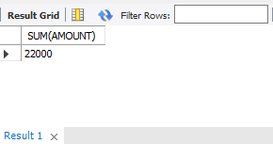

2.SELECT SUM(AMOUNT) FROM DEPOSIT;

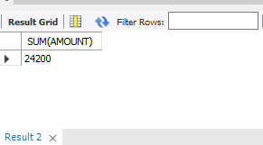

3.SELECT MAX(AMOUNT) FROM BORROW WHERE BNAME ='KAROLBAGH';

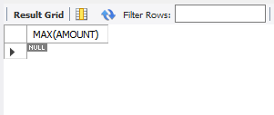

4.SELECT SUM(AMOUNT) from deposit where adate>'1995-03-01';

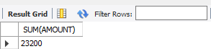

5.SELECT SUM(D1.AMOUNT) FROM DEPOSIT D1 , CUSTOMER C1 WHERE C1.CITY = 'NAGPUR' AND C1.CNAME = D1.CNAME;

6.SELECT MAX(D1.AMOUNT) FROM DEPOSIT D1 , CUSTOMER C1 WHERE C1.CITY

= 'Bombay' AND C1.CNAME = D1.CNAME;

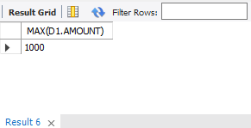

7.SELECT SUM(AMOUNT) from deposit,BRANCH where city='BOMBAY';

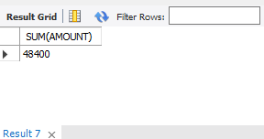

8.

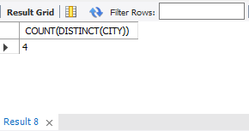

9.SELECT count(city) from CUSTOMER;

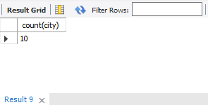

10.SELECT BNAME , SUM(AMOUNT) FROM DEPOSIT GROUP BY BNAME;

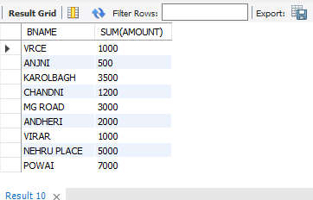

11.SELECT C1.CITY , SUM(D1.AMOUNT) FROM CUSTOMER C1 , DEPOSIT D1 WHERE D1.CNAME = C1.CNAME GROUP BY C1.CITY;

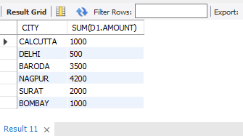

12.SELECT BNAME , SUM(AMOUNT) FROM BORROW

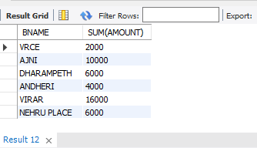

13.SELECT BORROW,CUSTOMER WHERE city ='NAGPUR' GROUP BY BNAME;

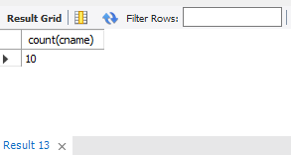

14.SELECT count(cname) from CUSTOMER;

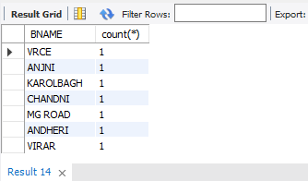

15.SELECT BNAME, count(*) from DEPOSIT, CUSTOMER where deposit.CNAME CUSTOMER.CNAME group by BNAME;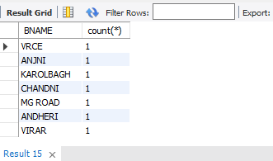

16.SELECT BNAME, count(*) from DEPOSIT, CUSTOMER where deposit.CNAME = CUSTOMER.CNAME group by BNAME;

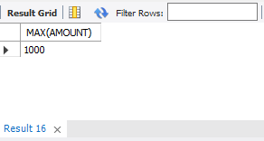

17select count(customer.CNAME) from customer where customer.CNAME IN (select deposit.cname from deposit) and customer.CNAME IN (select borrow.cname from borrow);

**Aim**

To familiarize with join or cartesian product

## Questions

1Give name of customers having living city BOMBAY and branch city NAGPUR

2.Give names of customers having the same living city as their branch city

3.Give names of customers who are borrowers as well as depositors and having city NAGPUR.

4.Give names of borrowers having deposit amount greater than 1000 and loan amount greater than 2000.

5.Give names of depositors having the same branch as the branch of Sunil

6.Give names of borrowers having loan amount greater than the loan amount of Pramod 7.Give the name of the customer living in the city where branch of depositor Sunil is located. 8.Give branch city and living city of Pramod

9.Give branch city of Sunil and branch city of Anil

10.Give the living city of Anil and the living city of Sunil

# Procedure

use ddl;

**1:** SELECT D1.CNAME,D1.BNAME,C1.CNAME,C1.CITY,B1.CITY,B1.BNAME FROM DEPOSIT D1,CUSTOMER C1,BRANCH B1 WHERE C1.CITY = 'BOMBAY' AND B1.CITY = 'NAGPUR' AND D1.CNAME = C1.CNAME AND D1.BNAME = B1.BNAME;

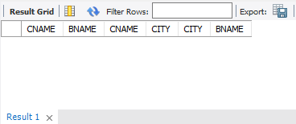

**2:** SELECT DISTINCT(CUSTOMER.CNAME), BRANCH.CITY FROM BRANCH, CUSTOMER WHERE BRANCH.CITY = CUSTOMER.CITY;

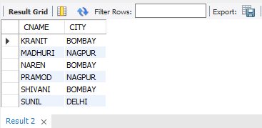

**3:** SELECT C1.CNAME FROM CUSTOMER C1,DEPOSIT D1,BORROW B1 WHERE C1.CITY='NAGPUR' AND C1.CNAME=D1.CNAME AND D1.CNAME = B1.CNAME;

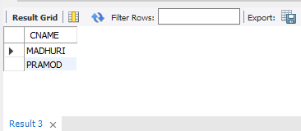

**4:** SELECT BR1.CNAME, BR1.AMOUNT, D1.CNAME, D1.AMOUNT FROM BORROW BR1,DEPOSIT D1 WHERE D1.CNAME = BR1.CNAME AND D1.AMOUNT > 1000 AND BR1.AMOUNT > 2000;

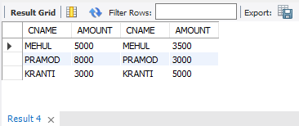

**5:** SELECT D1.CNAME FROM DEPOSIT D1 WHERE D1.BNAME IN (SELECT D2.BNAME FROM DEPOSIT D2 WHERE D2.CNAME = 'SUNIL');

C:\Users\Student\Pictures\6\5.png

**6:** SELECT BR1.CNAME, BR1.AMOUNT FROM BORROW BR1 WHERE BR1.AMOUNT > ALL (SELECT BR2.AMOUNT FROM BORROW BR2 WHERE BR2.CNAME = 'PRAMOD');

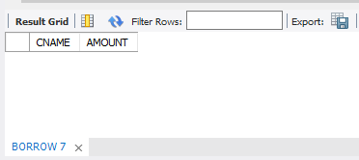

7: SELECT C.CNAME FROM CUSTOMER C WHERE C.CITY IN (SELECT B.CITY FROM BRANCH B WHERE B.BNAME IN (SELECT D.BNAME FROM DEPOSIT D WHERE D.CNAME='SUNIL'));

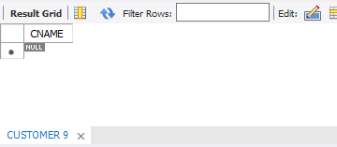

8: SELECT B1.CITY , C1.CITY FROM BRANCH B1,CUSTOMER C1, DEPOSIT D1 WHERE C1.CNAME = 'PRAMOD' AND C1.CNAME = D1.CNAME AND D1.BNAME = B1.BNAME;

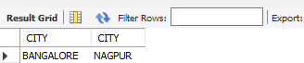

9: SELECT B1.CITY FROM DEPOSIT D1, BRANCH B1 WHERE D1.BNAME = B1.BNAME AND D1.CNAME IN ('SUNIL' ,'ANIL');

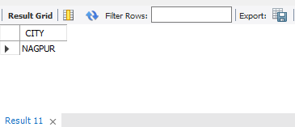

10: SELECT C1.CNAME, C1.CITY FROM CUSTOMER C1 WHERE C1.CNAME = 'ANIL' OR C1.CNAME = 'SUNIL';

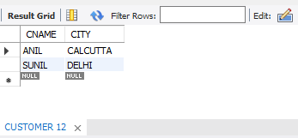

**AIM**

To familiarize with Group by and Having clause

Questions

1.List the branches having sum of deposit more than 5000.

2.List the branches having sum of deposit more than 500 and located in city BOMBAY

3.List the names of customers having deposited in the branches where the average deposit is more than 5000.

4.List the names of customers having maximum deposit

5.List the name of branch having highest number of depositors?

6.Count the number of depositors living in NAGPUR.

7.Give names of customers in VRCE branch having more deposite than any other customer in same branch

8.Give the names of branch where number of depositors is more than 5

9.Give the names of cities in which the maximum number of branches are located

10.Count the number of customers living in the city where branch is located

**OUTPUT**

1.List the branches having sum of deposit more than 5000.

SELECT D.BNAME FROM DEPOSIT D, BRANCH B WHERE

D.BNAME=B.BNAME AND B.CITY='BOMBAY' GROUP BY D.BNAME HAVING

SUM(D.AMOUNT)>5000;

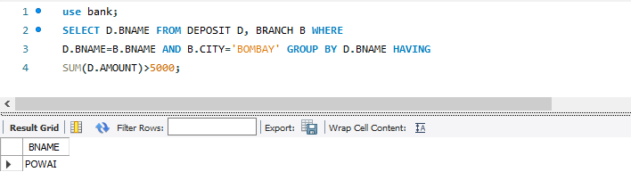

2.List the branches having sum of deposit more than 500 and located in city BOMBAY

SELECT D.BNAME FROM DEPOSIT D, BRANCH B WHERE

D.BNAME=B.BNAME GROUP BY D.BNAME HAVING SUM(D.AMOUNT)>5000;

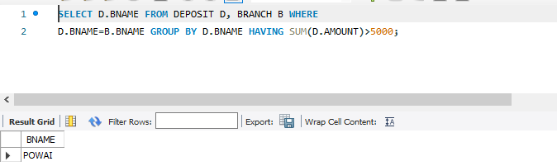

3.List the names of customers having deposited in the branches where the average deposit is more than 5000.

SELECT CNAME from deposit where AMOUNT=(select AVG(Amount) from DEPOSIT

GROUP BY BNAME having AVG(Amount)>5000);

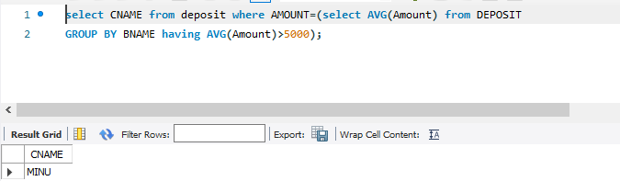

4.List the names of customers having maximum deposit

SELECT MAX(AMOUNT),CNAME FROM deposit;

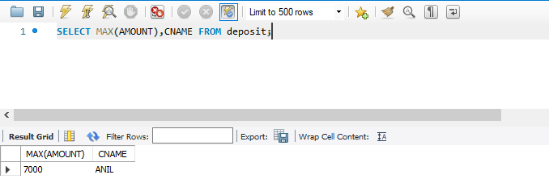

5.List the name of branch having highest number of depositors?

SELECT D1.BNAME FROM DEPOSIT D1 GROUP BY D1.BNAME HAVING

COUNT(D1.CNAME) > = ALL (SELECT COUNT (D2.CNAME) FROM DEPOSIT D2

GROUP BY D2.BNAME);

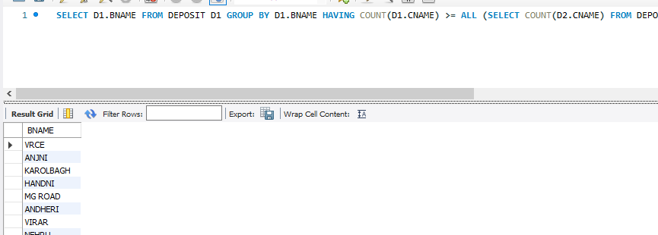

6.Count the number of depositors living in NAGPUR.

select count(deposit.cname)from deposit,CUSTOMER where

CUSTOMER.CITY='nagpur';

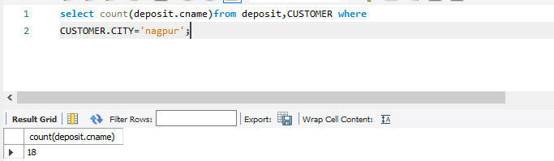

7.Give names of customers in VRCE branch having more deposite than any other customer in same branch

Select CNAME from deposit where BNAME='VRCE' and amount=(select

max(AMOUNT) from deposit where BNAME='VRCE');

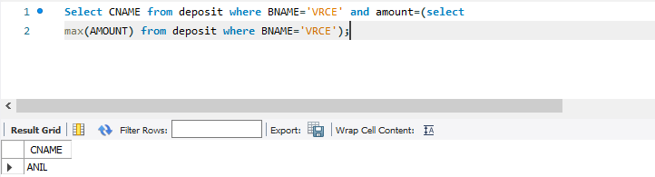

8.Give the names of branch where number of depositors is more than 5

SELECT BNAME from deposit GROUP BY BNAME HAVING

COUNT(BNAME)>5;

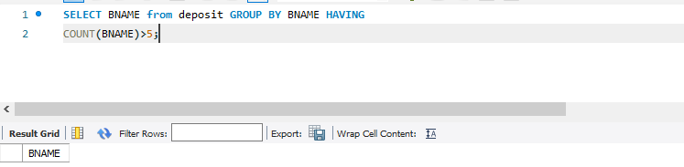

9.Give the names of cities in which the maximum number of branches are located

select C.CNAME ,count(B.BNAME) from CUSTOMER C inner join Branch B on

C.CNAME=B.BNAME group by C.Cname order by count(B.BName) DESC;

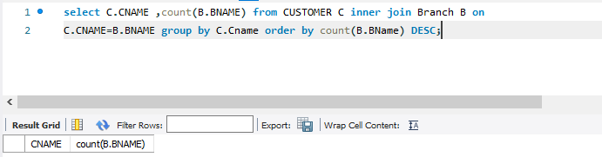

10.Count the number of customers living in the city where branch is located

select count(b1.bname) From deposit d1 , borrow b1 , customer c1 Where

c1.cname=d1.cname and d1.cname=b1.cname and c1.city in (select city from customer);

